Lab Exercise 3- Working with Docker Networking

Step 1: Understanding Docker Default Networks
Docker provides three default networks:
- bridge: The default network when a container starts.
- host: Bypasses Docker’s network isolation and attaches the container directly to the host network.
- none: No networking is available for the container.

1.1. Inspect Default Networks
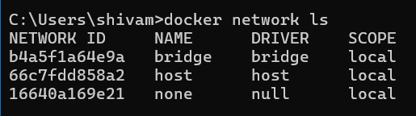
1.2. Inspect the Bridge Network
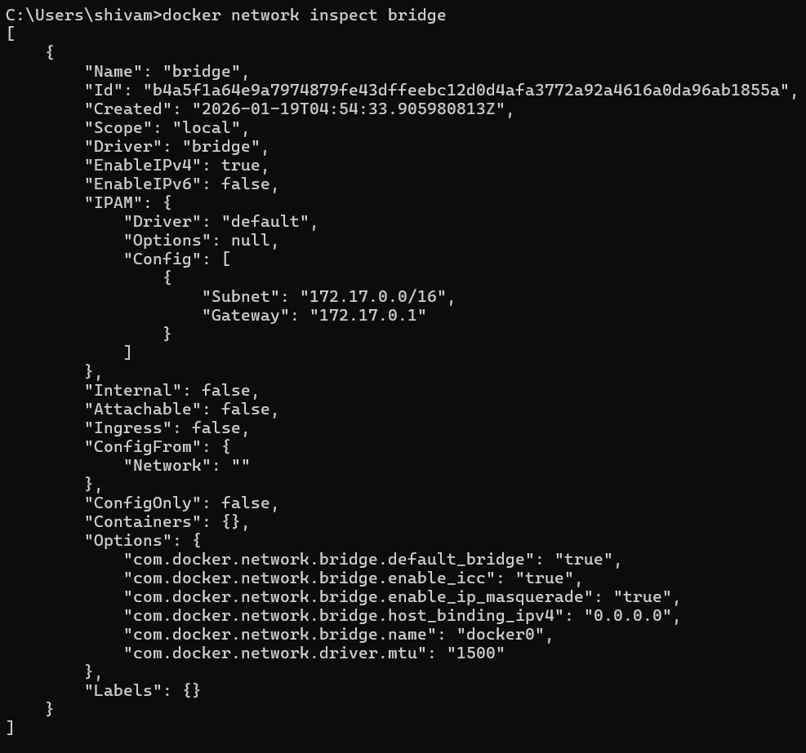This command will show detailed information about the bridge network, including the connected containers and IP address ranges.
Step 2: Create and Use a Bridge Network
2.1. Create a User-Defined Bridge Network
A user-defined bridge network allows containers to communicate by name instead of IP.
2.2. Run Containers on the User-Defined Network
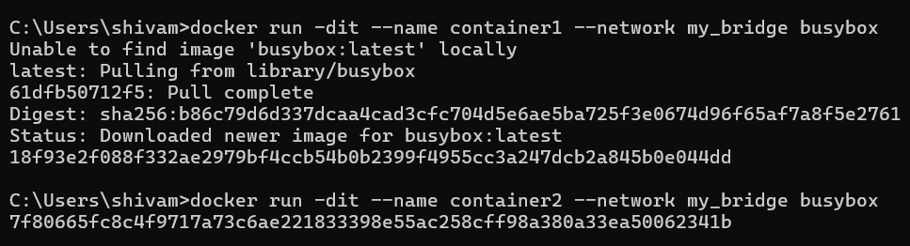2.3. Test Container Communication
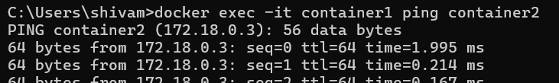
Step 3: Disconnect and Remove Networks 3.1. Disconnect Containers from Networks . 3.2 Remove Networks
To remove the user-defined network: and
Stop and remove all containers created during this exercise:

